J. Ohlemacher Assignment 1

## 1. Using R Crabs dataset: ##https://stat.ethz.ch/R-manual/R-devel/library/MASS/html/crabs.html

## 2. Load Crabs Dataset  
library(MASS)  
data(crabs)

## 3. Print descriptive stats for Crabs Dataset  
summary_crabs <- summary(crabs)  
print(summary_crabs)

## sp sex index FL RW CL   
## B:100 F:100 Min. : 1.0 Min. : 7.20 Min. : 6.50 Min. :14.70   
## O:100 M:100 1st Qu.:13.0 1st Qu.:12.90 1st Qu.:11.00 1st Qu.:27.27   
## Median :25.5 Median :15.55 Median :12.80 Median :32.10   
## Mean :25.5 Mean :15.58 Mean :12.74 Mean :32.11   
## 3rd Qu.:38.0 3rd Qu.:18.05 3rd Qu.:14.30 3rd Qu.:37.23   
## Max. :50.0 Max. :23.10 Max. :20.20 Max. :47.60   
## CW BD   
## Min. :17.10 Min. : 6.10   
## 1st Qu.:31.50 1st Qu.:11.40   
## Median :36.80 Median :13.90   
## Mean :36.41 Mean :14.03   
## 3rd Qu.:42.00 3rd Qu.:16.60   
## Max. :54.60 Max. :21.60

## Mean, Min, Max of BD  
mean_BD <- mean(crabs$BD)  
min_BD <- min(crabs$BD)  
max_BD <- max(crabs$BD)  
print(mean_BD)

## [1] 14.0305

print(min_BD)

## [1] 6.1

print(max_BD)

## [1] 21.6

## Frequency table of species (categorical variable summary stat)  
freqtable_sp <- table(crabs$sp)  
print(freqtable_sp)

##   
## B O   
## 100 100

## 3. Transform variable  
  
## Group by species and sex  
library(dplyr)

##   
## Attaching package: 'dplyr'

## The following object is masked from 'package:MASS':  
##   
## select

## The following objects are masked from 'package:stats':  
##   
## filter, lag

## The following objects are masked from 'package:base':  
##   
## intersect, setdiff, setequal, union

species_sex_group <- crabs %>% group_by(sp,sex)  
print (species_sex_group)

## # A tibble: 200 × 8  
## # Groups: sp, sex [4]  
## sp sex index FL RW CL CW BD  
## <fct> <fct> <int> <dbl> <dbl> <dbl> <dbl> <dbl>  
## 1 B M 1 8.1 6.7 16.1 19 7   
## 2 B M 2 8.8 7.7 18.1 20.8 7.4  
## 3 B M 3 9.2 7.8 19 22.4 7.7  
## 4 B M 4 9.6 7.9 20.1 23.1 8.2  
## 5 B M 5 9.8 8 20.3 23 8.2  
## 6 B M 6 10.8 9 23 26.5 9.8  
## 7 B M 7 11.1 9.9 23.8 27.1 9.8  
## 8 B M 8 11.6 9.1 24.5 28.4 10.4  
## 9 B M 9 11.8 9.6 24.2 27.8 9.7  
## 10 B M 10 11.8 10.5 25.2 29.3 10.3  
## # ℹ 190 more rows

## Scale BD  
scaled_BD <- scale(crabs$BD)  
print(scaled_BD)

## [,1]  
## [1,] -2.052837226  
## [2,] -1.936041139  
## [3,] -1.848444074  
## [4,] -1.702448965  
## [5,] -1.702448965  
## [6,] -1.235264616  
## [7,] -1.235264616  
## [8,] -1.060070486  
## [9,] -1.264463638  
## [10,] -1.089269508  
## [11,] -0.914075377  
## [12,] -0.768080268  
## [13,] -0.768080268  
## [14,] -0.914075377  
## [15,] -0.884876355  
## [16,] -0.768080268  
## [17,] -0.884876355  
## [18,] -0.826478312  
## [19,] -0.797279290  
## [20,] -0.563687116  
## [21,] -0.388492985  
## [22,] -0.096502767  
## [23,] -0.242497876  
## [24,] -0.184099832  
## [25,] -0.125701789  
## [26,] -0.125701789  
## [27,] -0.125701789  
## [28,] 0.137089407  
## [29,] 0.049492342  
## [30,] 0.107890385  
## [31,] 0.487477669  
## [32,] 0.399880603  
## [33,] 0.253885494  
## [34,] 0.341482560  
## [35,] 0.253885494  
## [36,] 0.253885494  
## [37,] 0.458278647  
## [38,] 0.312283538  
## [39,] 0.458278647  
## [40,] 0.604273756  
## [41,] 0.575074734  
## [42,] 0.808666908  
## [43,] 0.633472778  
## [44,] 1.100657126  
## [45,] 1.100657126  
## [46,] 0.808666908  
## [47,] 1.100657126  
## [48,] 1.334249300  
## [49,] 1.246652235  
## [50,] 1.743035605  
## [51,] -2.315628422  
## [52,] -1.848444074  
## [53,] -1.848444074  
## [54,] -1.848444074  
## [55,] -1.819245052  
## [56,] -1.527254834  
## [57,] -1.644050921  
## [58,] -1.498055813  
## [59,] -1.673249943  
## [60,] -1.439657769  
## [61,] -1.702448965  
## [62,] -1.352060704  
## [63,] -1.147667551  
## [64,] -1.060070486  
## [65,] -1.176866573  
## [66,] -1.060070486  
## [67,] -0.914075377  
## [68,] -1.030871464  
## [69,] -0.884876355  
## [70,] -0.826478312  
## [71,] -0.622085159  
## [72,] -0.855677333  
## [73,] -0.738881246  
## [74,] -0.797279290  
## [75,] -0.855677333  
## [76,] -0.738881246  
## [77,] -0.680483203  
## [78,] -0.622085159  
## [79,] -0.271696898  
## [80,] -0.446891028  
## [81,] -0.592886137  
## [82,] -0.008905702  
## [83,] -0.008905702  
## [84,] -0.154900811  
## [85,] -0.067303745  
## [86,] -0.300895919  
## [87,] 0.195487451  
## [88,] -0.067303745  
## [89,] -0.067303745  
## [90,] 0.195487451  
## [91,] -0.184099832  
## [92,] 0.078691364  
## [93,] 0.020293320  
## [94,] 0.370681582  
## [95,] -0.038104723  
## [96,] 0.341482560  
## [97,] 0.399880603  
## [98,] 0.750268865  
## [99,] 0.867064952  
## [100,] 1.188254191  
## [101,] -1.936041139  
## [102,] -1.468856791  
## [103,] -1.410458747  
## [104,] -1.147667551  
## [105,] -0.943274399  
## [106,] -0.826478312  
## [107,] -0.563687116  
## [108,] -0.534488094  
## [109,] -0.592886137  
## [110,] -0.534488094  
## [111,] -0.271696898  
## [112,] -0.154900811  
## [113,] -0.271696898  
## [114,] -0.213298854  
## [115,] -0.330094941  
## [116,] -0.388492985  
## [117,] -0.154900811  
## [118,] -0.359293963  
## [119,] -0.271696898  
## [120,] -0.008905702  
## [121,] -0.038104723  
## [122,] -0.154900811  
## [123,] 0.049492342  
## [124,] 0.195487451  
## [125,] 0.137089407  
## [126,] 0.487477669  
## [127,] 0.633472778  
## [128,] 0.370681582  
## [129,] 0.604273756  
## [130,] 0.779467886  
## [131,] 0.721069843  
## [132,] 0.896263974  
## [133,] 0.925462995  
## [134,] 1.071458104  
## [135,] 0.954662017  
## [136,] 0.867064952  
## [137,] 1.013060061  
## [138,] 1.129856148  
## [139,] 1.100657126  
## [140,] 1.129856148  
## [141,] 1.159055170  
## [142,] 1.626239518  
## [143,] 1.567841475  
## [144,] 2.005826801  
## [145,] 1.918229736  
## [146,] 1.772234627  
## [147,] 2.064224845  
## [148,] 1.889030714  
## [149,] 2.181020932  
## [150,] 2.210219954  
## [151,] -1.235264616  
## [152,] -1.264463638  
## [153,] -0.914075377  
## [154,] -0.738881246  
## [155,] -0.622085159  
## [156,] -0.417692007  
## [157,] -0.388492985  
## [158,] -0.446891028  
## [159,] -0.330094941  
## [160,] -0.213298854  
## [161,] -0.008905702  
## [162,] 0.020293320  
## [163,] -0.067303745  
## [164,] -0.067303745  
## [165,] -0.067303745  
## [166,] -0.008905702  
## [167,] -0.038104723  
## [168,] -0.096502767  
## [169,] 0.195487451  
## [170,] 0.166288429  
## [171,] 0.458278647  
## [172,] 0.575074734  
## [173,] 0.166288429  
## [174,] 0.429079625  
## [175,] 0.487477669  
## [176,] 0.925462995  
## [177,] 0.604273756  
## [178,] 0.545875712  
## [179,] 0.691870821  
## [180,] 0.750268865  
## [181,] 0.283084516  
## [182,] 0.750268865  
## [183,] 0.370681582  
## [184,] 0.808666908  
## [185,] 0.925462995  
## [186,] 1.217453213  
## [187,] 1.129856148  
## [188,] 1.129856148  
## [189,] 1.071458104  
## [190,] 1.334249300  
## [191,] 1.159055170  
## [192,] 1.509443431  
## [193,] 1.509443431  
## [194,] 1.013060061  
## [195,] 1.743035605  
## [196,] 1.363448322  
## [197,] 1.626239518  
## [198,] 1.597040496  
## [199,] 1.684637562  
## [200,] 2.064224845  
## attr(,"scaled:center")  
## [1] 14.0305  
## attr(,"scaled:scale")  
## [1] 3.424772

## 4. Plot one quantitative variable and one scatterplot  
library(ggplot2)  
  
boxplot(crabs$BD)

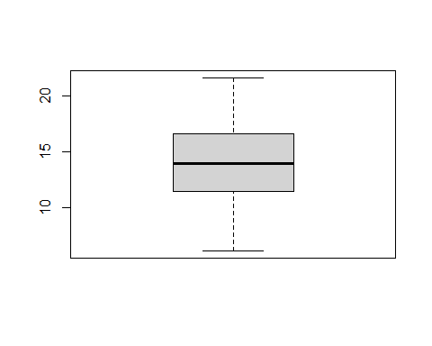

## Scatterplot  
data(crabs)   
plot(crabs$CL, crabs$CW, main = "CL vs CW Scatterplot", xlab = "CL", ylab = "CW", pch = 16, col = "blue")

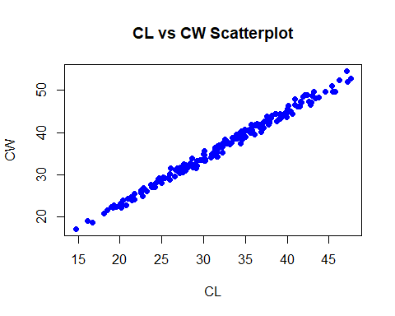

## Plot one quantitative variable  
ggplot(crabs, aes(x = BD, y = factor(sp))) +  
 geom_point() +  
 labs(x = "Body Depth (BD)", y = "Species") +  
 theme_minimal()

